**بسم الله الرحمن الرحيم**

Sol-HW2

**الحل غير كامل**

**PART I:**

1. The variable y is stored in **Data** section.
2. The parameters argc, *argv the parameters, methods, and reference are stored in **Stack**.
3. The pointer *values is stored in **Stack**.
4. The actual data is stored in **Heap.**
5. The variable i is stored in **Stack**.

**PART II:**



**Code:**

#include <stdio.h>

#include <unistd.h>

#include <sys/types.h>

#include <stdlib.h>

int main() {

pid_t id = fork();

if ( id > 0 ){

sleep(1);

system("ps -l");

}

else{

exit(0);

}

return 0;

}

**State of the Processes:**

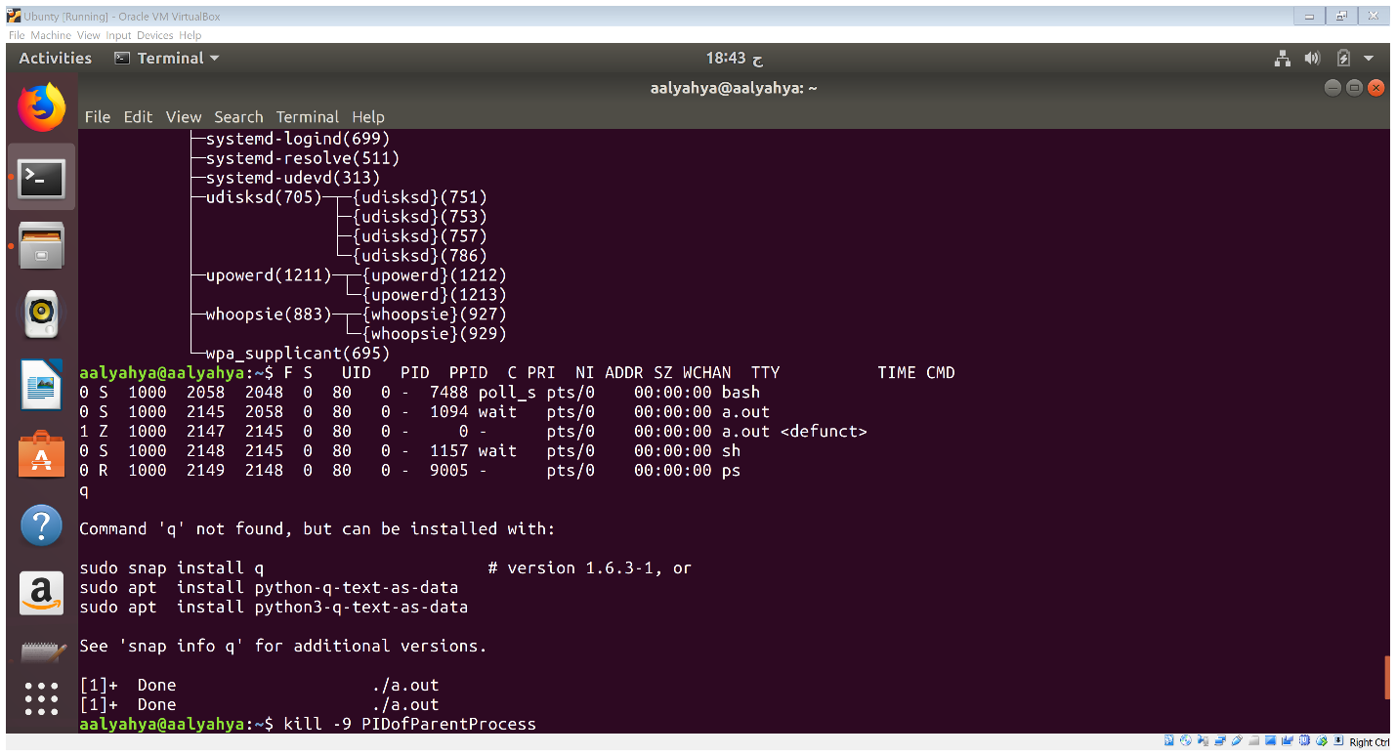



parent process ID is 2145,

child process ID is 2147.

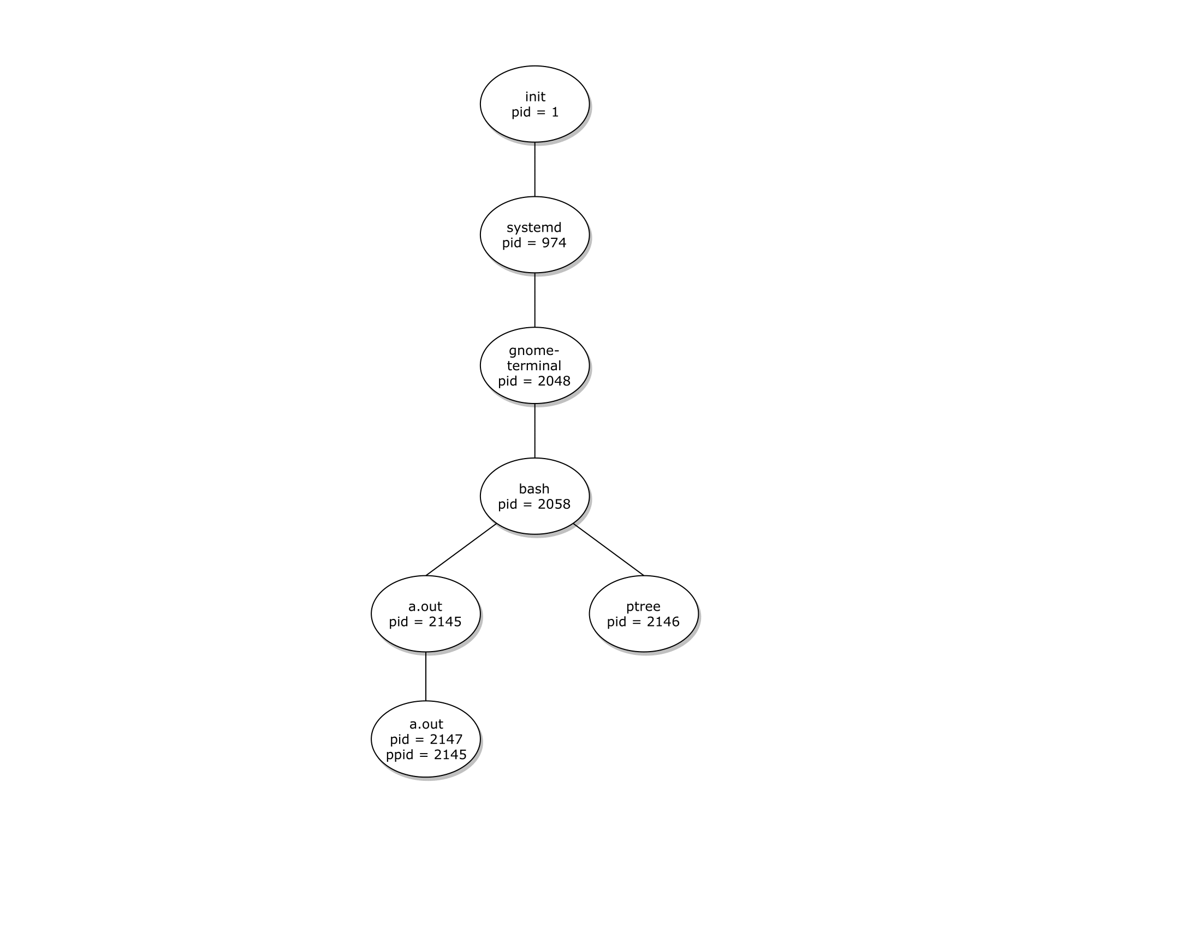**Process Tree:**



